Inflation Worksheet

Introduction: The Big Bang Theory successfully predicts many phenomena of our early universe such as the expansion of the universe, the age of the universe, the evolution of galaxies, and primordial nucleosynthesis. However, there were some problems with this theory …

1) Thermal Equilibrium
[In Class Demo] There is a class size of around 30 people. I give one person a piece of paper having the word “Inflation” on it and tell him to tell his closest neighbors what the word was. The neighbors then tell their neighbors what the word is (Technically, the person should tell the neighbors who KNOW the word the word as well. This avoids exponential growth which is incorrect.) This process repeats until everyone in the class knows what the word is. This isn’t a PERFECT analogy because in thermal equilibrium, the temperatures “balance out”, resulting in a value in between the two starting values.
a) Knowing this, tell me how thermal equilibrium works in an empty room where one wall initially starts out at 100 degrees C (not fixed) while the remainder of the room is at 25 degrees C.

b) After say 1 hour, the room will be in thermal equilibrium. Estimate the temperature of the wall and the rest of the room.

c) With the same initial conditions, if the room suddenly increased in volume about 10¹⁵ times (wall increases as well), estimate how long would it take to reach thermal equilibrium?

d) Is it easier for the wall to reach thermal equilibrium with a small room or a large room?

*Note: The temperature of the large room won’t change that much because the volume of the room is MUCH greater than the area of the wall.
2) The Horizon Problem
a) What direction do we look at if we want to see the Cosmic Microwave Background (CMB)?

b) What temperature will we detect the CMB to be at?

c) The CMB is technically “everywhere”, but it occurred in the past at redshift of z=1000. Thus, the time between us and the CMB is denoted by the “lookback time” of 13.7 billion years. The CMB is a “wall” that we cannot see past because the Universe was opaque before the time of Recombination. Thus, you can imagine a hypothetical sphere of radius 13.7 billion lightyears surrounding the Earth denoting the CMB that we see (The actual distance is > 13.7 billion lightyears because the expansion of the Universe is accelerating but we’ll ignore that tidbit for now). What is the distance from one side of the sphere to the opposite side of the sphere?

d) How long would it take light to travel from one end to the opposite end?

e) The two opposite sides of the CMB are not in “causal contact” meaning it isn’t possible to have “communicated” with each other to reach the same temperature. Why not?

3) The Flatness Problem
a) According to standard Big Bang Theory, what happens to the curvature of the universe throughout time?

b) We know that Ω_{total} = 1.0 ± 0.02 which dictates that the universe is flat today. Given the graph below (Ω_{matter} on the y-axis), what happens to Ω_{m} if it starts out farther from 1 initially? Does it diverge faster or slower?
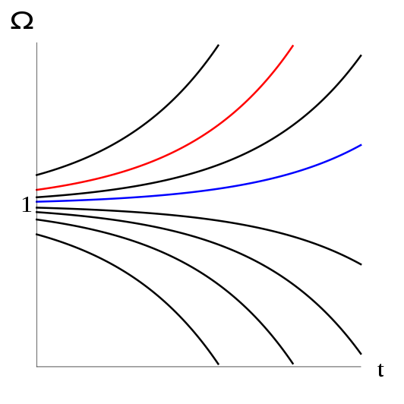
c) Ω_{matter} is known as an equilibrium value. This can be explained by the pencil-in-a-room analogy. If you come into a room and you want the pencil to be standing on its tip, is it easier to come into the room finding the pencil already on the tip or for you to have to put the pencil on the tip? You must be really lucky for the pencil to be standing on the tip initially. Thus, are we lucky that the Universe just happened to start at very, very, very close to Ω_{m} = 1? Does today’s Ω_{m} depend strongly on the initial Ω_{m}?

Inflation to the Rescue!
4) Inflation Theory
a) Define inflation for me.

5) Solution to the Flatness Problem
a) Kobe Bryant gives you a basketball and asks you to live on it. If you stand on the basketball, can you tell what shape and what respective type of universe it was (open/closed)?

b) Say the basketball expanded to the size of Earth. What curvature would you say the “universe” has if you were standing on the Earth-basketball?

c) What curvature would you say it has if you were standing on a Google satellite floating outside the atmosphere?

d) Now, say the basketball-Earth expands to astronomical scales, such as the size of a supercluster! What curvature would you think the basketball-supercluster has if you were standing on its surface?

e) This geometric picture is a simplified version of the solution to the flatness problem. What it’s saying is that the exponential increase in the size of the Universe actually removes the strong dependency of Ω_{m} today to Ω_{m} in the past. This is because the “observable” Universe is only a “local” portion of the “global” universe. Using the geometric analogy, what happens to the “local” geometry as the Universe expands?

6) Solution to the Horizon Problem
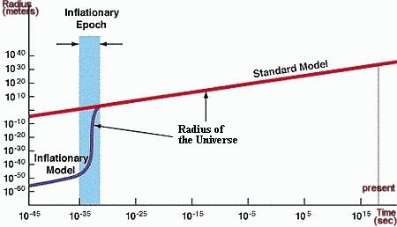

a) Using the graph above, what was the size of the Universe before the inflationary epoch? Describe qualitatively.

b) With this size of the universe in the past, was it possible for thermal equilibrium to occur? Describe qualitatively.

c) How does this explain how two causally disconnected regions of the CMB (cannot be connected unless exceeding speed of light) can be at the same temperature?

BONUS: After going through this worksheet and finding out that inflation has solved so many problems about our universe, is it smart to let inflation solve the problems of our US government?

